Salisbury Township Fire Safety: Tot finder
Salisbury Township Fire Inspector Office and Public Safety is taking part in the TOT FINDER FIRE SAFETY PROGRAM. The new Tot Finder™ Fire Safety Program is designed to help alert firefighters to the location of a child's bedroom in the event of a fire. The new Tot Finder™ Fire Safety Stickers are now designed to be used inside the home. The larger, oval sticker is to be placed on the bottom of the child's bedroom door, below the door handle, and the smaller, rectangular stickers are to be placed on either side of the door jambs. The front of the stickers are produced on a highly reflective material while the back is made of a special removable adhesive so they can be removed easily when the child no longer occupies that room.
Ages: 0 to 10, Actual Size: 3 1/4" x 5"
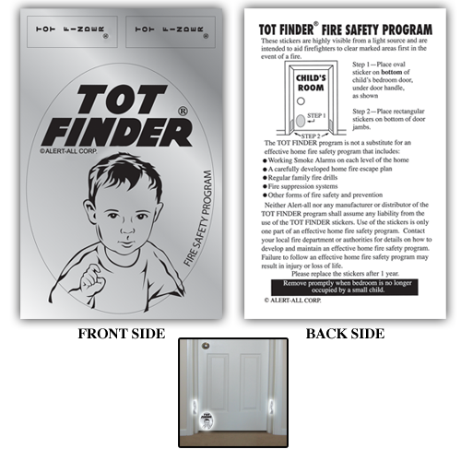
To acquire a TOTFINDER sticker, please visit the Salisbury Township Police Station at 3000 S. Pike Ave., Allentown, PA 18103. If you have questions, please contact the fire inspection office at (610)-797-1447 or your local fire station: Western Salisbury Fire Department (610)-437-6600 or www. westernsalisbury.org and Eastern Salisbury Fire Company (610)-797-5227.
Please remember other important fire safety such as keep your smoke detectors working on every level of your home, practice safe cooking, and have an escape plan.
Stay Safe.

